Weapons of Mass Destruction? Rapa Nui *Mata’a* Morphometric Analyses

November 15, 2014

Carl P. Lipo1, Terry L. Hunt2, Rene Horneman1, Vincent Bonhomme3,4

1Department of Anthropology and IIRMES, California State University Long Beach, Long Beach, CA 90840 carl.lipo@csulb.edu

2Robert D. Clark Honors College, 129 Chapman Hall, 1293 University of Oregon, Eugene, OR 97403-1293 U.S.A

3 School of Mathematics and Statistics, The University of Sheffield, S10 2 TN Sheffield, United-Kingdom.

4UMR 5059 CBAE, Centre de Bio-Archéologie et d'Ecologie, 34000 Montpellier, France.

Rapa Nui (Easter Island, Chile) is a tiny island located in a remote corner of Eastern Polynesia, more than 2000 km from the nearest inhabited body of land (Figure 1). Polynesians first colonized the island when they sailed from central East Polynesia in voyaging canoes during the 13th century AD (Hunt & Lipo 2006; Wilmshurst et al. 2011). Despite the island's diminutive size, remoteness, and limited natural resources, the archaeological record of Rapa Nui is well-known for its nearly 1000 multi-ton statues known as *moai* that once sat atop massive stone platforms known as *ahu* (Hunt & Lipo 2011a).

The dramatic prehistoric investment in monumental architecture stands in marked contrast to the Rapa Nui's environment and historically observed population levels. Even at the first point of European contact, the island was largely devoid of trees and population sizes were roughly 3000 individuals (Hunt & Lipo 2011a). While earlier researchers (e.g., Heyerdahl & Ferdon 1961a; Heyerdahl 1989) believed the depleted and depauperate state of the island was due to previous conflict between Polynesians and elite from South America, more recent researchers have interpreted the contrast between the spectacular nature of the archaeological record and the sparse environment of the island as the outcome of an environmental catastrophe (Bahn & Flenley 1992; Flenley & Bahn 2003). These researchers argue based largely on oral traditions that prehistoric populations grew in numbers until resource use exceeded the carrying capacity and the island underwent catastrophic demographic collapse. This account has been popularized as the "collapse" scenario (*sensu* Diamond 1995, 2005).

New research, however, challenges this notion with empirical evidence generated from the archaeological record that the Rapanui flourished on the island until AD 1722 when Europeans brought diseases and other social disruptions (Hunt 2007; Hunt & Lipo 2007; Hunt & Lipo 2009a; Hunt & Lipo 2009b; Hunt & Lipo 2011a; Hunt & Lipo 2011b; Lipo & Hunt 2009; Mulrooney et al. 2009; Mulrooney 2012; Rainbird 2002). Investigations on Rapa Nui's settlement patterns demonstrate that the island's inhabitants lived in a dispersed and low-density fashion (Hunt & Lipo 2011a; Morrison 2012). In addition, studies show that subsistence was largely based on extensive use of lithic mulch gardens to that boosted the nutrient-poor soil to a level that sustained sweet potato cultivation (Bork et al. 2004; Ladefoged et al. 2005; Ladefoged et al. 2010; Ladefoged et al. 2013; Mieth et al. 2006; Stevenson & Haoa 2002; Stevenson et al. 2006). Finally, the demise of the once extensive palm tree forest appears to have had nothing to do with statue construction or changes in carry capacity (Hunt & Lipo 2011a; Lipo et al. 2013).

One persistent claim about "collapse" is that prehistoric Rapa Nui populations engaged in intense warfare when resources became scarce (Bahn & Flenley 1992; Diamond 1995, Diamond (2005); Flenley & Bahn 2003). While, intertribal prehistoric warfare is often associated with the toppling of stone statues (e.g., Bahn & Flenley 1992), the existence of fallen statues does not necessarily imply warfare. Natural explanations are more likely (Edwards et al. 1996) and are documentation points to their post-contact timing (Hunt & Lipo 2011a). Significantly, no evidence exists on the island for defensive structures (Hunt & Lipo 2011a; Lipo & Hunt 2014). We are largely left with evidence for prehistoric warfare on Rapa Nui oral traditions recorded in the 20th century (e.g., Routledge 1919). These accounts have an unknown relation to prehistory and, as Metraux (1940) has argued, most are likely recent introductions.

One lingering line of empirical evidence used to support arguments about prehistoric warfare is the presence of *mata’a*, flaked obsidian stemmed tools (Diamond 2005; Metraux 1940). *Mata’a* are commonly found on the island and have narrow stems and wide blades. Their form is similar to artifacts found on other Polynesian islands such basalt and chert tools known from New Zealand, Pitcairn and the Chatham Islands (Balfour 1917; Metraux 1957: 232; Skinner 1958) as well as obsidian examples from New Britain, Papua New Guinea (e.g., Araho 1997; Specht *et al.* 1988; Torrence *et al.* 2009a; Torrence *et al.* 2009b; Torrence et al. 2013). On Rapa Nui, their “spear-like” qualities well as oral tradition underlay assumptions that *mata’a* were weapons and thus are linked to the presumed “collapse” (e.g., Diamond 2005).

In the current analysis, we seek to explore whether the shape of *mata’a* indicates their use as weapon and/or can be used to infer the functional environment in which these artifacts interacted. Using an image database of 423 *mata’a*, we conduct quantitative morphometric analyses using elliptical Fourier transforms to investigate whether specific shape classes might be inferred. Morphometric analyses enable one to explore shape as a continuous property of objects rather than nominal categories (Bookstein 1982; Bookstein *et al.* 1985; Bookstein 1997; Cardillo 2010; Kendall 1989). Morphometrics makes no assumptions about shape: it just turns form into orthogonal quantitative variables. Consequently, we can use multivariate analyses and ordination approaches to test if particular clusters of shapes map to particular locations, environments, or source material. In this way, we argue that it is possible to evaluate hypotheses regarding the potential functions of *mata’a.*

# Approach

*Mata’a* have been noted since the earliest European visitors described the island. Members of Cook's expedition to the island commented that the islanders “had lances or spears made of thin ill-shaped sticks, and pointed with a sharp triangular piece of black glassy lava” (von Saher 1990: 35). These early visitors often assumed *mata’a* were "spears" due to their resemblance to European varieties rather than any direct observation of their use. Scars noted by early European observers may havebeen inflicted by *mata’a* though there is no clear evidence that their use was violent or lethal. For example, in his voyage to Rapa Nui in 1770, Captain Don Felipe González (Haedo & Roggeveen 1908:99) remarked that "they [Rapanui] possess no arms, and although in some we observed sundry wounds on the body, which we thought to have been inflicted by cutting instruments of iron or steel, we found that they proceeded from stones, which are their only [weapons of] defence and offence, and as most of these are sharp edged they produce the injury referred to."

As we see in other aspects of comments about the island, there is tendency for these early European observers to interpret what they saw with culturally biased preconceptions (Hunt and Lipo 2011). To avoid making assumptions, we can examine the physical evidence of *mata’a* for clues to their function. The physical features of *mata’a* should reflect the range of interactions that occurred between the artifact and the environment and provide a means of studying variability in their use through time or over space.

*Mata’a* are one of the most numerous shaped artifact classes on Rapa Nui (Figure 2). Overall, they vary in size, but average 6-10 cm in width and length. Technologically, they are formed from unifacial flakes created by hard hammer percussion on obsidian cores quarried from one of the island's four obsidian sources. Most of the shaping of *mata’a* occurs during the creation of a stem through unifacial flaking. Lenticular in cross section, the stem is formed from one of the lateral margins of the original flake while the blade constitutes the remaining distal and opposite lateral edges. Overall, the blade shape is dominated by the shape of the parent flake though occasionally there is shaping through secondary flaking and resharpening. Frequently, areas of cortex are left on one face of the tool.

Researchers have noted that *mata’a* blades take a variety of shapes that range from rounded to sub-angular to angular to complex (Mulloy 1961). Early researchers attempted to assign *mata`a* shapes to what they considered ethnographic categories using Rapanui words (i.e., Routledge 1919). Later attempts to construct systematic classifications have also focused on identifying types based on characterizations of overall shape (e.g., Mulloy 19061).

None of these classification efforts produced meaningful categories. Mulloy (1961: 151), for example, argued that “no significant clustering or correlations could be extracted.... the material represents a continuous range of variation without objective natural order, and that the only classification possible must involve the subjective selection of ideal types from infinite series of possibilities, and the arbitrary reference of intermediate forms to one or another of these.” Mulloy concluded that manufacturing procedures dictated differences in overall shape of *mata’a* and were best explained by chance.

This result is not surprising. The overall shape of an object is rarely a useful dimension for problem-oriented classification (Dunnell 1986). Artifact forms are influence by a variety of processes including technological constraints of the material, performance aspects that depend upon the range of environments in which the object is used, as well as simple idiosyncratic variability related to the manufacturer and the process of production. In the case of *mata’a,* much of the variability in blade shape can be explained as the contingent results involved in the stages of manufacture (Bollt *et al.* 2006). Difference in shape, therefore, may have been a determinant of the range and kinds of activities for which each tool was primarily used. Studies of use-wear on *mata’a* support this notion; there appear to have been multiple functions that include scraping and cutting (Church & Rigney 1994; Church & Ellis 1996).

A recent study of *mata’a* shape at the scale of assemblages using deterministic frequency seriation as a means for examining how class frequencies changed over space and through time that *mata’a* forms vary in a remarkably continuous fashion (Lipo *et al.* 2010). The seriation results suggest that at least some of the variability in *mata’a* form, particular shoulder angles and stem shape, was inherited through the social learning between individuals. The evidence also indicates that variability in *mata’a* form is not directly associated with *mata’a* performance in its use environment but simply a feature of the individual making the object. Overall, our growing understanding of *mata’a* variability continues to support their form being related to domestic and cultivation activities and not weapons involved in warfare (Bollt *et al.* 2006; Lipo *et al.* 2010).

In our analysis here, we focus on *mata’a* variability in the blade portion of the *mata’a* relative to the stem. We assume that as hafted objects the point at the center of the stem where it meets the blade can be held constant to allow for comparisons. We also assume that due to performance the functional aspects of the tool will result in shape variability that is more constrained than aspects of shape that have no performance effects and are effectively stylistic attributes (Lipo et al. 2012). Constraints related to performance are assumed to sort shape variability in proportion to the benefits/drawbacks. Based on this notion, we hypothesize that:

* If *mata’a* are weapons, the distal end of the artifact will be constrained in its shape.
* If *mata’a* are weapons, the distal end of the artifact will show a tendency towards a spear-like shape that is consistent with the penetration of enemies or prey. If *mata’a* are not weapons, there will be no such shape restriction the distal end of the tool.

# Methods and Data

In order to test these hypotheses, we used morphometrics, a quantitative analysis of form in terms of shape and size, in two or more dimensions (Bookstein 1982; Bookstein *et al.* 1985; Bookstein 1997; Cardillo 2010; Kendall 1989; Rohlf 1990). Morphometric approaches have huge advantages over traditional studies of shape using global shape descriptors, or lengths and ratios of lengths. First, morphometrics avoids the problem of nominal shape (e.g., "triangular", "square", "round") by transforming the overall shape into independent, quantitative variables. Then, with techniques available for standardizing position, scale and rotation, morphometrics allows one to explore, compare and test for differences in the shape (form minus size) of artifacts. Additionally, a single set of coefficients can be used to characterize a single shape (where different shapes can have the same eccentricity, ratios of lengths, etc.). Last but not least, morphometrics are information-preserving: shapes can be reconstructed using their morphometric coefficients.

Modern morphometrics consider the overall geometry of the shape and can be obtained in a number of ways. With roots in biology, the earliest form of morphometrics focused on identifying the location of specific landmarks (e.g., Thompson 1917). A landmark approach requires defining features that are to be examined as to how they relate to each other. In the case of artifacts such as *mata’a,* there are few consistent landmarks to hold constant other than perhaps the distal and proximal ends. One can also conduct an analysis of what is known as "semi-landmarks," a fixed number of regularly positioned points around the outline of an object (Bookstein 1997; Gunz & Mitteroecker 2013). Both approaches to measuring shape make use of the relative positions between all points (Bookstein 1991; 1997). When landmarks are absent, too few, or not consistent among shapes we use the entire geometry of the outline of the shapes, when projected on a plane (i.e., top, lateral, polar views). *Mata’a* shapes are clearly in the second case, and we used outline analysis on semilandmarks.

In our morphometric analyses we make use of *Momocs* v0.99 (<http://CRAN.R-project.org/package=Momocs>), an R package (R Core Team 2014) developed by Bonhomme (2012; Bonhomme et al. 2014) that implements morphometric and outline analysis using elliptical Fourier transforms (Kuhl & Giardina, 1982; Giadina & Kuhl 1977). Our dataset consisted of planview photographs artifacts sourced from museum and field collections (Figure 3). We used a collection of 118 *mata’a* from 4 site locations that are currently housed at the P. Sebastian Englert Museum on Rapa Nui. We also included 8 *mata’a* published by Heyerdahl (Heyedahl & Ferdon 1961a) and 6 images of *mata’a* that Hunt and Lipo (2008)photographed during pedestrian surveys of land parcels on the south coast of Rapa Nui. Finally, we included photographs of 291 objects that are housed Bishop Museum, Honolulu, Hawai'i (Mulrooney et al. 2014: 5–6). Mulrooney and colleagues took photos of these *mata’a* during their study of obsidian sourcing via pXRF (Mulrooney et al. 2014). Despite the fact that we do not have specific provenience information for these artifacts, we are able to use this collection to examine potential shape variability that might vary as a function of obsidian source (Figure 3). This shape variability could be potentially caused by systematic material differences or by the differential use of *mata’a* at different locations. In total, our data set includes 423 *mata’a*. Based on bootstrap estimates of basic metrics (Figure S1), this sample size is large enough to adequately characterize shape and overall *mata’a* configuration.

In our analyses, we assumed that *mata’a* are the hafted portions of compound tools that are otherwise incompletely preserved in archaeological deposits. Based on evidence of use wear on the distal edges (Church & Rigney 1994; Church & Ellis 1996), we assume that the overall *mata’a* shape is a functional element (*sensu* Dunnell 1978), the portion of the artifact that interacts with the environment. Consequently, our interest is on those aspects of shape that potentially affect function and thereby come under natural selection. The task of explaining variability in shape consists of identifying selective pressures that affect the performance of shape and to determine whether their magnitude is sufficiently great to impact fitness. The greater the selective pressures on performance, the more constraint we would expect in those aspects of shape. If the effect on function and performance is sufficiently small, then other forces such as technological (i.e., material source, manufacturing steps, etc.) or stylistic (stochastic or neutral) processes may be posited as having played a role in structuring the shapes of *mata’a*, as well as when and where they occur in the archaeological record. In aspects of shape not under selection, we would expect to see a greater range of variability. It is possible, however, that not all *mata’a* instances were used in the same way. If *mata’a* shape is influenced by more than one function, either contemporaneously or over time, then the selective context will differ and thus the “cause” of *mata’a* shape should vary. In this scenario we would expect to see modal patterns of *mata’a* shape where outline variants form statistically-distinguishable groups.

# Data

To ensure that the shapes were directly comparable, we aligned scaled and oriented photos of *mata’a* at the point where the midpoint of the stem meets the blade. We converted the images to binary format and used TPSDig software (Rohlf 2014) to create outlines of each *mata’a* consisting of 200 sets of X-Y coordinates located equidistantly along the perimeter of each artifact (Figure 4).

Simple metrics of length and width (Figure 5) indicate that there is a single distribution of these objects without clear-cut modes in size. Comparisons of length and width, however, are crude descriptions of shape. A more direct means of evaluating shape variability is accomplished by superimposing *mata’a* outlines (Figure 6). This process required selecting a standard reference point for all objects from which measurements are made. We chose a reference point at the center of the haft where it intersects the blade.

From this reference point, we calculated the distance to the perimeter in one-degree intervals for the 360-degree perimeter. Comparing all of the measures at a specific angle across all *mata’a* enables us to examine where shape varies and where it is more constrained (Figure 7). Based on the 95% confidence intervals for all of the radial distances, *mata’a* shape varies the least at the point where the stem intersects the blade. Stem length, however, varies significantly as does the overall length of the distal blade edge. This finding suggests that the most important part of the shape of the *mata’a* is its ability to be hafted. The majority of *mata’a* shape is not strongly constrained.2

# Morphometric Analyses: Elliptic Fourier Analysis

With morphometrics, we can go further and exam the degree to which shape variability may form groups that are related to specific functions. In this effort, Fourier-based analyses are powerful tools for studying shape variability (Claude 2008; Bonhomme 2014). Fourier approaches treat shape as a periodic function that can be fitted using a sum of simple trigonometric functions such as sine and cosine. These simple functions are frequencies that are integer multiples, i.e. are harmonics, of one another. Lower harmonics provide approximation for the coarse-scale trends in the original periodic function while the high-frequency harmonics fit its fine-scale variations3 (Figure 8). Coefficients, or the amplitude of the trigonometric functions, are used as quantitative variables.

Based on the elliptical Fourier characterizations of the *mata’a* we can examine the shapes to determine if there are clusters of shape that might distinguish sub-groups from each other. Figure 9 presents the position of *mata’a* shapes on a factorial map with shapes reconstructed from the first two principal component axes (gathering 45% of the total variance). Based on these data we do not have discrete shape groups: *mata’a* are highly variable in outline shape and there are continuous intermediate shapes between all variants. While there are a few *mata’a* with long and narrow blades, there are more *mata’a* whose shapes diverge greatly. These results fail to indicate any subgroup that might have been specifically built as lethal weapons and supports the notion that *mata’a* have no particular function for which blade shape affects performance. Given observations of use-wear on the blade edges (e.g., Church 1998; Church & Rigney 1994; Church & Ellis 1996; Stevenson & Cardinali 2008: 107), it is likely that this means that *mata’a* simply must have an edge sufficient for cutting and scraping.

We can also examine the *mata’a* to see if there are systematic differences between the locations from which *mata’a* are found or between the obsidian sources used to make the artifacts. In our analyses, we used *mata’a* from 4 sites on Rapa Nui (Table S1 and S2). Figure 10 presents the distribution of sets of *mata’a* from multiple locations across the island (Figure 2). The graph includes the 50% Gaussian confidence ellipses for each of the 4 sites and the underlying grid represents the morphological space based on the first two principal components. The overlap of the groups indicates that the shapes from each of the sites cannot be distinguished. The same conclusion can be drawn from the analysis of the shape variability relative to obsidian source (Figure 11). Overall, there is no evidence that *mata’a* blade shape was constrained due to functional performance.

# Comparison with stemmed tools from other Pacific Islands

The *mata’a* of Rapa Nui share similarity with stone tools found on other islands across the Pacific. On New Britain in Melanesia, for example, Torrence (2009a, 2009b, 2013) has described stemmed obsidian tools that are similar to *mata’a*. Torrence (see also Kononenko 2012) argues that these tools may have been used for a range of activities including tattooing and ritual scarification. An additional but limited comparison can be made with Pitcairn Island, where a few stemmed lithic tools have been found (Heyerdahl & Ferdon 1961b). Pitcairn Island is a remote Eastern Polynesian island that is located ca. 1900 km to the west of Rapa Nui. Historically-related Polynesian populations inhabited the island, though it was abandoned during prehistory. Stemmed lithics of chert known as locally as *mataa* are also found on the Chatham Islands and on New Zealand (Jones 1981).

As a comparison for our study, we generated outlines of examples of stemmed lithic tools from published images using the same procedure as for Rapa Nui (Table S3). Our elliptic Fourier analyses of shape variability required 13 harmonics to adequately characterize the shape of all of the stemmed artifacts (Figure 12). While the sample sizes of the non-Rapa Nui assemblages are small, when we compare the shapes of Rapa Nui *mata’a* with those other objects, we find that the Pitcairn Island stemmed artifacts have overall shapes that are quite distinct. While we cannot rule out the possibility that the Pitcairn examples are a few extremely long and pointed shapes that happen to have been collected from a much wider array of variability, these shapes are certainly more consistent with hafted tools for hunting or weapons. New Zealand *mataa* are similar but have substantially thicker stems than the Rapa Nui artifacts. Jones (1981) suggests that this might reflect tools that are hafted with the edge perpendicular to the shaft such as an adze. Given their chert composition and relatively steep edge angles, this shape might be well suited for activities such as woodworking.

The New Britain artifacts, on the other hand, show a wide array of features that are more like the ones from Rapa Nui. Based on this comparison, it is conceivable that one of the Rapa Nui *mata’a* functions reflect the same kinds of uses that are thought to characterize the New Britain tools. Tattooing is known from Rapa Nui through ethno-historic observation (Huish 1839: 77; Métraux 1940; Thomson 1891: 22) and as markings on the prehistoric *moai* (Lee 1992). It would not be surprising that at least some of the *mata’a* objects were used in tattooing and scarification practices, though their numbers and widespread distribution suggests that they were likely not all used in this fashion.

# Conclusion

Our investigation of shape variability for Rapa Nui *mata’a* fails to support hypotheses about the potential use of these objects as weapons. While the notion that Rapa Nui prehistory consists of a tale of collapse and self-destruction remains popular, the evidence to support this claim is non-existent. In addition to a lack of defensive structures and skeletal evidence of lethal violence (Hunt & Lipo 2011a), from the so-called "weapons of mass destruction" (Keegan 1993) when we take a careful look at the shape of *mata’a* we simply do not see evidence that these classes of artifacts represent lethal weapons (see also Ingersoll & Ingersoll 2013). There appears to have been no performance requirements that strongly influenced the blade shape. Other than having a sharp edge, *mata’a* are no more lethal than any other kind of rock. Indeed, as documented in post-contact Rapa Nui, rock throwing from high points is the primary way in which native Rapanui fought off intrusion of Europeans and is far more likely to represent potential lethal weapons than *mata’a* (e.g., Roggeveen's 1722 visit, Eyzaguirre et. al 1908).

Our conclusion that *mata’a* had more than one function is not surprising and it is essential to resist the notion that any object is imbibed with an inherent function (Dunnell 1978). Instead, we measure function on the empirical variability for assemblages of objects (Dunnell *et al.* 1976). In the case of *mata’a* the wear patterns and distribution in rock mulch suggest that at least some of these objects were employed in cultivation. We also cannot rule out that they were used in tattooing and scarification practices. The latter function is consistent with observations of healed scars made by Spanish visitors in AD 1770 (Eyzaguirre *et al.* 1908).

It is unfortunate that in the case of Rapa Nui the myth of its prehistory continues to persist despite the lack of evidence to support it. In Rapa Nui archaeology, tradition has long trumped empirical inquiry as can be seen in claims about *mata’a* as weapons rather than a part of subsistence and social dimensions of prehistoric Rapa Nui. In the case of Rapa Nui, getting the correct answer is far from a trivial academic exercise. The island's prehistory is often used as an exemplar of the consequences of ignoring the impacts humans make on their environment. In a sense, the assumptions about *mata’a* leads to potentially erroneous conclusions. United Kingdom Prime Minister Margaret Thatcher, for example, famously used Rapa Nui as a warning in a 1989 presentation to the General Assembly of United Nations (e.g., Thatcher 1989). Similarly, *mata’a* have been used as examples of mass effect "weapons" in a study of terrorist tactics (Rasmussen & Hafez 2010). Given the contemporary importance that Rapa Nui has in guiding our concerns for our future, we owe it to ourselves to make certain that we fully understand the prehistory of the island and that our understanding is based on well-documented and thoroughly researched evidence.

# ACKNOWLEDGEMENTS

The authors would like to thank Francisco Torres Hochstetter, Director of the P. Sebastian Englert Museum, Hanga Roa, Isla de Pascua, Chile for kindly assisting us with this work. We would also like to thank Mara Mulrooney for sharing her compositional data for the Bishop Museum *mata’a.* Thanks are also due to Joanne Minerbi for her work in preparing the images. Rene Horneman was supported for this project through an undergrad research assistant program offered by the CSULB Office of Research and Sponsored Programs.

# References Cited

Araho, N. 1997. Obsidian stemmed tools from west New Britain, Papua New Guinea. Unpublished Masters of Philosophy Dissertation, University of Sydney, Sydney.

Bahn, P. & J. Flenley 1992. *Easter Island, Earth Island.* Thames, London.

Balfour, H. 1917. Some ethnological suggestions in regard to Easter Island, or Rapanui. *Folklore* 28: 356–81.

Bollt, R., J.E. Clark, P.R. Fisher & H.K. Yoshida 2006. An experiment in the replication and classification of Easter Island *mata’a.* *Rapa Nui Journal* 20: 125–33.

Bonhomme, V. 2012. *A graphical introduction to Momocs and outline analysis using R.* <http://www.vincentbonhomme.fr/Momocs/vignettes/>.

Bonhomme, V., S. Picq, C. Gaucherel & J. Claude 2014. Momocs: Outline analysis using R. *Journal of Statistical Software* 56: 1–24.

Bookstein, F.L. 1982. Foundations of morphometrics. *Annual Review of Ecology and Systematics* 13: 451–70. [http://www.filogenetica.org/cursos/deluna/morfometria/referencias en pdf/Bookstein82.pdf](http://www.filogenetica.org/cursos/deluna/morfometria/referencias%20en%20pdf/Bookstein82.pdf).

— 1991. *Morphometrics tools for landmarks data*. Cambridge University Press, New York.

— 1997. Landmark methods for forms without landmarks: Morphometrics of group differences in outline shape. *Medical Image Analysis* 1: 225–43. <http://femininebeauty.info/i/bookstein.sliding.pdf>.

Bookstein, F.L., B. Chernoff, R.L. Elder, J. Humphries, G.R. Smith & R.E. Strauss 1985. *Morphometrics in evolutionary biology: The geometry of size and shape change, with examples from fishes.* Academy of Natural Sciences of Philadelphia, Philadelphia.

Bork, H.R., A. Mieth & B. Tschochner. 2004. Nothing but stones? A review of the extent and technical efforts of prehistoric stone mulching on Rapa Nui. *Rapa Nui Journal* 18: 10–14.

Bowman, A. 2009. Review of ’Morphometrics with R.’ *Journal of Statistical Software* 31: 1–2.

Cardillo, M. 2010. Some applications of geometric morphometrics to archaeology, in A. Elewa (ed.) *Morphometrics for non-Morphometricians*: 325–41. Springer-Verlag, New York.

Church, F. 1998. Upland, lowland, citizen, chief: Patterns of use-wear from five Easter Island sites, in G.L. Christopher M. Stevenson & F.J. Morin (ed.) *Easter island in Pacific Context South Seas Symposium: Proceedings of the fourth international conference on Easter Island and East Polynesia*: 312–15. Easter Island Foundation, Los Osos, CA.

Church, F. & G. Ellis. 1996. A use-wear analysis of obsidian tools from an Ana Kionga. *Rapa Nui Journal* 10: 81–88.

Church, F. & J. Rigney 1994. A microwear analysis of tools from site 10-241, Easter Island–An inland processing site. *Rapa Nui Journal* 8: 101–5.

Claude, J. 2008. *Morphometrics with R*. Springer, New York.

Diamond, J. 1995. Easter’s end. *Discover* 9: 62–69.

— 2005. *Collapse: How societies choose to fail or succeed*. Viking, New York.

Dunnell, R.C. 1978. Style and function: A fundamental dichotomy*. American Antiquity* 43: 192–202.

— 1986. Methodological issues in Americanist artifact classification. *Advances in* *Archaeological Method and Theory* 9: 149–207.

Dunnell, R.C., D.E. Lewarch & S.K. Campbell 1976. Test excavations at the Hamilton Island Site, 45-SA-12. Seattle: Dept. of Anthropology, University of Washington.

Edwards, E., R. Marchetti, L. Dominichetti & O. Gonzales-Ferran 1996. When the earth trembled, the statues fell. *Rapa Nui Journal* 10: 1–15.

Eyzaguirre, E.R.-T. (ed.) 2004. *Easter Island: The first three expeditions*. Easter Island: Rapanui Press.

Flenley, J. & P.G. Bahn 2003. The enigmas of Easter Island: Island on the edge. New York: Oxford University Press.

Giardina, C. R. and F. P. Kuhl 1977. Accuracy of curve approximation by harmonically related vectors with elliptical loci. *Computer Graphics and Image Processing* 6(3):277-285

Gunz, P. & P. Mitteroecker 2013. Semilandmarks: A method for quantifying curves and surfaces. *Hystrix, the Italian Journal of Mammology* 24: 103–9. <http://www.italian-journal-of-mammalogy.it/article/download/6292/pdf_6292>.

Haedo, F.G. de. & J. Roggeveen. 1908. The voyage of captain don Felipe González: In the ship of the line San Lorenzo, with the frigate Santa Rosalia in company, to Easter Island in 1770-1. Cambridge: Hakluyt society.

Heyerdahl, T. 1989. *Easter island–the mystery solved*. London: Souvenir Press.

Heyerdahl, T. & E. Ferdon. 1961a. Reports of the Norwegian archaeological expedition to Easter Island and the East Pacific. Vol. 1. London: Allen, Unwin.

— 1961b. Reports of the Norwegian archaeological expedition to Easter Island and the East Pacific. Vol. 2. London: Allen, Unwin.

Huish, R. 1839. A narrative of the voyages and travels of Captain Beechey, to the pacific and Behring’s straits; performed in the years 1825, 26, 27 and 28. For the purpose of co-operating with the expeditions under Captains Parry and Pranklin. and of Captain Back, R.N., to the Thlew-ee-choh river & the arctic sea, in search of the expedition under Capt. J. Ross, R.N., being the conclusion of the series of voyages instituted for the discovery of the North West Passage. W. Wright, Southwark.

Hunt, T.L. 2007. Rethinking Easter Island’s ecological catastrophe*. Journal of Archaeological Science* 34: 485–502.

Hunt, T.L. & C.P. Lipo. 2006. Late colonization of Easter island. *Science* 311: 1603–6.

Hunt, T.L. & C.P. Lipo. 2007. Chronology, deforestation, and ‘collapse:’ evidence vs. faith in Rapa Nui prehistory. *Rapa Nui Journal* 21: 85–97.

— 2008. Results of the 2008 Rapa Nui Field Survey. Report on file at the P. Sebastian Englert Museum, Hanga Roa, Isla de Pascua.

— 2009a. Revisiting Rapa Nui (Easter Island) ‘ecocide.’ *Pacific Science* 63: 601–16.

— 2009b. Ecological catastrophe, collapse, and the myth of `ecocide’ on Rapa Nui (Easter Island), in P.A. McAnany & N. Yoffee (ed.) *Questioning collapse: Human resilience, ecological vulnerability, and the aftermath of empire*: 21–44. New York: Cambridge University Press.

— 2011a. Easter Island’s complex history. *Nature* 479: 41.

Hunt, T.L. & C.P. Lipo. 2011b. *The statues that walked*. New York: Simon & Schuster.

Ingersoll, D.W. & K.B. Ingersoll. 2013. Art of distraction: Rocking the farm, in B.D. Lundy (ed.) *The art of anthropology / the anthropology of art*: 23–64. Knoxville, Newfound Press.

Jones, K. 1981. New Zealand mataa from Marlborough, Nelson and the Chatham islands. *New Zealand Journal of Archaeology* 3: 89–107.

Keegan, J. 1993. *A history of warfare*. Vintage Books, New York.

Kendall, D. 1989. A survey of the statistical theory of shape. *Statistical Science* 4: 8–120.

Kononenko, N. 2012. Middle and late Holocene skin-working tools in Melanesia: Tattooing and scarification? *Archaeology in Oceania* 47: 14–28.

Kuhl, F. F. P., and C. C. R. Giardina 1977. Elliptic Fourier features of a closed contour. *Computer Graphics and Image Processing. 13(3): 236-258.*

Ladefoged, T., C. Stevenson, P. Vitousek & O. Chadwick 2005. Soil nutrient depletion and the collapse of Rapa Nui society. *Rapa Nui Journal* 19: 100–105.

Ladefoged, T.N., A. Flaws & C.M. Stevenson. 2013. The distribution of rock gardens on Rapa Nui (Easter Island) as determined from satellite imagery*. Journal of Archaeological Science* 40: 1203–12.

Ladefoged, T.N., C.M. Stevenson, S. Haoa, M. Mulrooney, C. Puleston, P.M. Vitousek. & O.A. Chadwick. 2010. Soil nutrient analysis of Rapa Nui gardening. *Archaeology in Oceania* 45: 80–85.

Lee, G. 1992. *Rock art of Easter Island: Symbols of power, prayers to the gods*. Institute of Archaeology, University of California, Los Angeles.

Lipo, C.P. & T.L. Hunt 2009. AD 1680 and Rapa Nui prehistory. *Asian Perspectives* 48: 309–17.

Lipo, C.P. & T.L. Hunt 2014. Easter Island, archaeological evidence, and the evolutionary history of warfare. Paper presented at the 79th Annual Society for American Archaeology meetings. Austin, TX.

Lipo, C.P., T.D. Hunt & R.C. Dunnell. 2012. Formal analyses and functional accounts of groundstone ‘plummets’ from Poverty Point, Louisiana. *Journal of Archaeological Science* 39: 84–91.

Lipo, C.P., T.L. Hunt & S.R. Haoa 2013. The ’walking’ megalithic statues (*moai*) of Easter Island. *Journal of Archaeological Science* 40: 2859–66.

Lipo, C.P., T.L. Hunt & B. Hundtoft 2010. Stylistic variability of stemmed obsidian tools (*mata’a*), frequency seriation, and the scale of social interaction on Rapa Nui (Easter Island). *Journal of Archaeological Science* 37: 2551–61.

Metraux, A. 1957. *Easter Island: A stone-age civilization of the Pacific*. Oxford University Press.

Métraux, A. 1940. Ethnology of Easter Island. Bishop Museum Press, Honolulu.

Mieth, A. H. Bork, J. McNeill & V. Winiwarter 2006. The dynamics of soil, landscape and culture on Easter Island (Chile). White Horse Press., Isle of Harris, UK.

Morrison, A. 2012. An archaeological analysis of Rapa Nui settlement structure: A multi-scalar approach. PhD dissertation, Department of Anthropology, University of Hawai’i, Manoa.

Mulloy, W. 1961. Ceremonial center of Vinapu, in T. Heyerdahl & E. Ferdon (ed.) *The archaeology of Easter Island*: 93–180. 24. Monograph of the School for American Research, the Kon Tiki Museum.

Mulrooney, M. 2012. Continuity or collapse? Diachronic settlement and land use in Hanga Ho`onu, Rapa Nui (Easter Island). PhD dissertation, Department of Anthropology, University of Auckland.

Mulrooney, M., T.N. Ladefoged, C.M. Stevenson & S. Haoa 2009. The myth of AD 1680: New evidence from Hanga Ho’Onu, Rapa Nui (Easter Island). *Rapa Nui Journal* 23: 94–105.

Mulrooney, M.A., A. McAlister, C.M. Stevenson, A.E. Morrison & L. Gendreau. In press. Sourcing Rapa Nui *mata`a* from the collections of Bishop Museum using non-destructive pXRF. *Journal of the Polynesian Society.*

Rainbird, P. 2002. A message for our future? The Rapa Nui (Easter Island) ecodisaster and Pacific island environments. *World Archaeology* 33: 436–51.

Rasmussen, M.J. & M.M. Hafez 2010. Terrorist innovations in weapons of mass effect: Preconditions, causes and predictive indicators. Workshop Report. The Defense Thread Reduction Agency, Advanced Systems, Concepts Office, Washington, D.C.

Rohlf, F.J. 1990. Morphometrics. *Annual Review of Ecology and Systematics* 21: 299–316.

— 2014. *TPS software*. <http://life.bio.sunysb.edu/ee/rohlf/software.html>.

Routledge, K. 1919. *The Mystery of Easter Island: The Story of an Expedition*. Sifton, Praed, London.

Skinner, H.D. 1958. Some recent publications relating to Easter Island culture and its probable history. *The Journal of the Polynesian Society* 67: 248–51.

Specht, J., R. Fullagar, R. Torrence & N. Baker 1988. Prehistoric obsidian exchange on Melanesia: A perspective from the Talasea sources. *Australian Archaeology*, 3–16.

Stevenson, C.M. & S.H. Cardinali. 2008. *Prehistoric Rapa Nui: Landscape and settlement archaeology at Hanga Ho’Onu*. Easter Island Foundation, Los Osos, CA.

Stevenson, C.M., T.L. Jackson, A. Mieth, H.-R. Bork & T.N. Ladefoged 2006. Prehistoric and early historic agriculture at Maunga Orito, Easter Island (Rapa Nui), Chile, *Antiquity* 80: 919–36.

Stevenson, C.M., T. Ladefoged & S. Haoa 2002. Productive strategies in an uncertain environment: prehistoric agriculture on Easter Island*. Rapa Nui Journal* 16(1):17-22.

Thatcher, M. 1989. Speech by Margaret Thatcher to United Nations General Assembly (Global Environment) 11/8/1989. Accessed 11/15/2015. <http://www.unep.org/Documents.Multilingual/Default.asp?DocumentID=2712&ArticleID=9462&l=en>.

Thompson, D.W. 1917. *On growth and form*. Cambridge University Press, Cambridge.

Thomson, W.J. 1891. *Te pito te henua; or, Easter Island*. Government Printing Office, Washington.

Torrence, R., S. Kelloway. & P. White. 2013. Stemmed tools, social interaction, and voyaging in early–mid Holocene Papua New Guinea. *The Journal of Island and Coastal Archaeology* 8: 278–310.

Torrence, R., P. Swadling, W. Ambrose, N. Kononenko, P. Rath & M. Glascock 2009. Obsidian stemmed tools and mid-Holocene interaction. *Asian Perspectives* 48: 118–47.

Torrence, R., P. Swadling, N. Kononenko, W. Ambrose, P. Rath & M.D. Glascock 2009. Mid-Holocene social interaction in Melanesia: New evidence from hammer-dressed obsidian stemmed tools. *Asian Perspectives* 48: 119–48. <http://scholarspace.manoa.hawaii.edu/bitstream/handle/10125/29084/AP_V48No1_torrence.pdf?sequence=1>.

von Saher, H. 1990. Some details from the journal of Captain Bouman on the discovery of Easter Island. *Rapa Nui Journal* 6: 34–39.

Wilmshurst, J.M., T.L. Hunt, C.P. Lipo & A. Anderson 2011. High-precision radiocarbon dating shows recent and rapid initial human colonization of East Polynesia. *Proceedings of the National Academy of Science* 108: 1815–20.



Figure 1. Location of Rapa Nui in Polynesia.

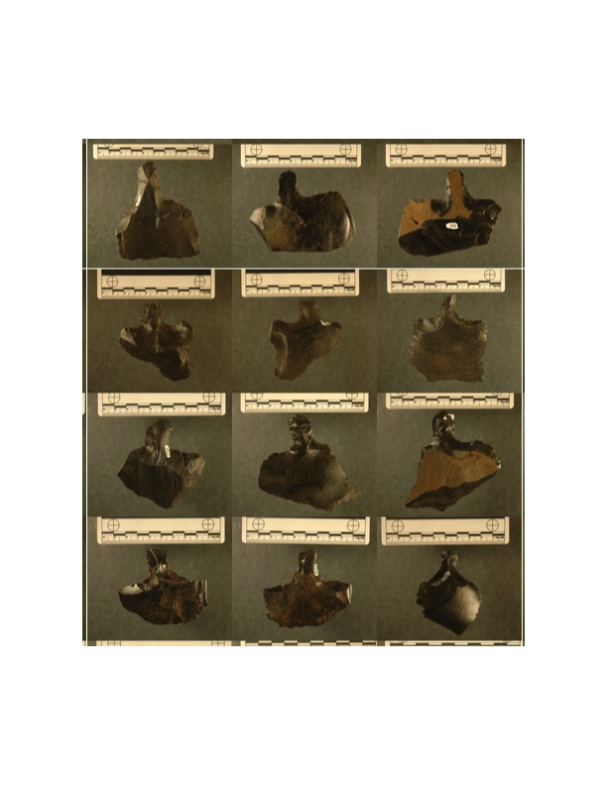

Figure 2. *Mata’a* examples from Rapa Nui.



Figure 3. Locations of *mata’a* collections and obsidian sources on Rapa Nui, Chile.

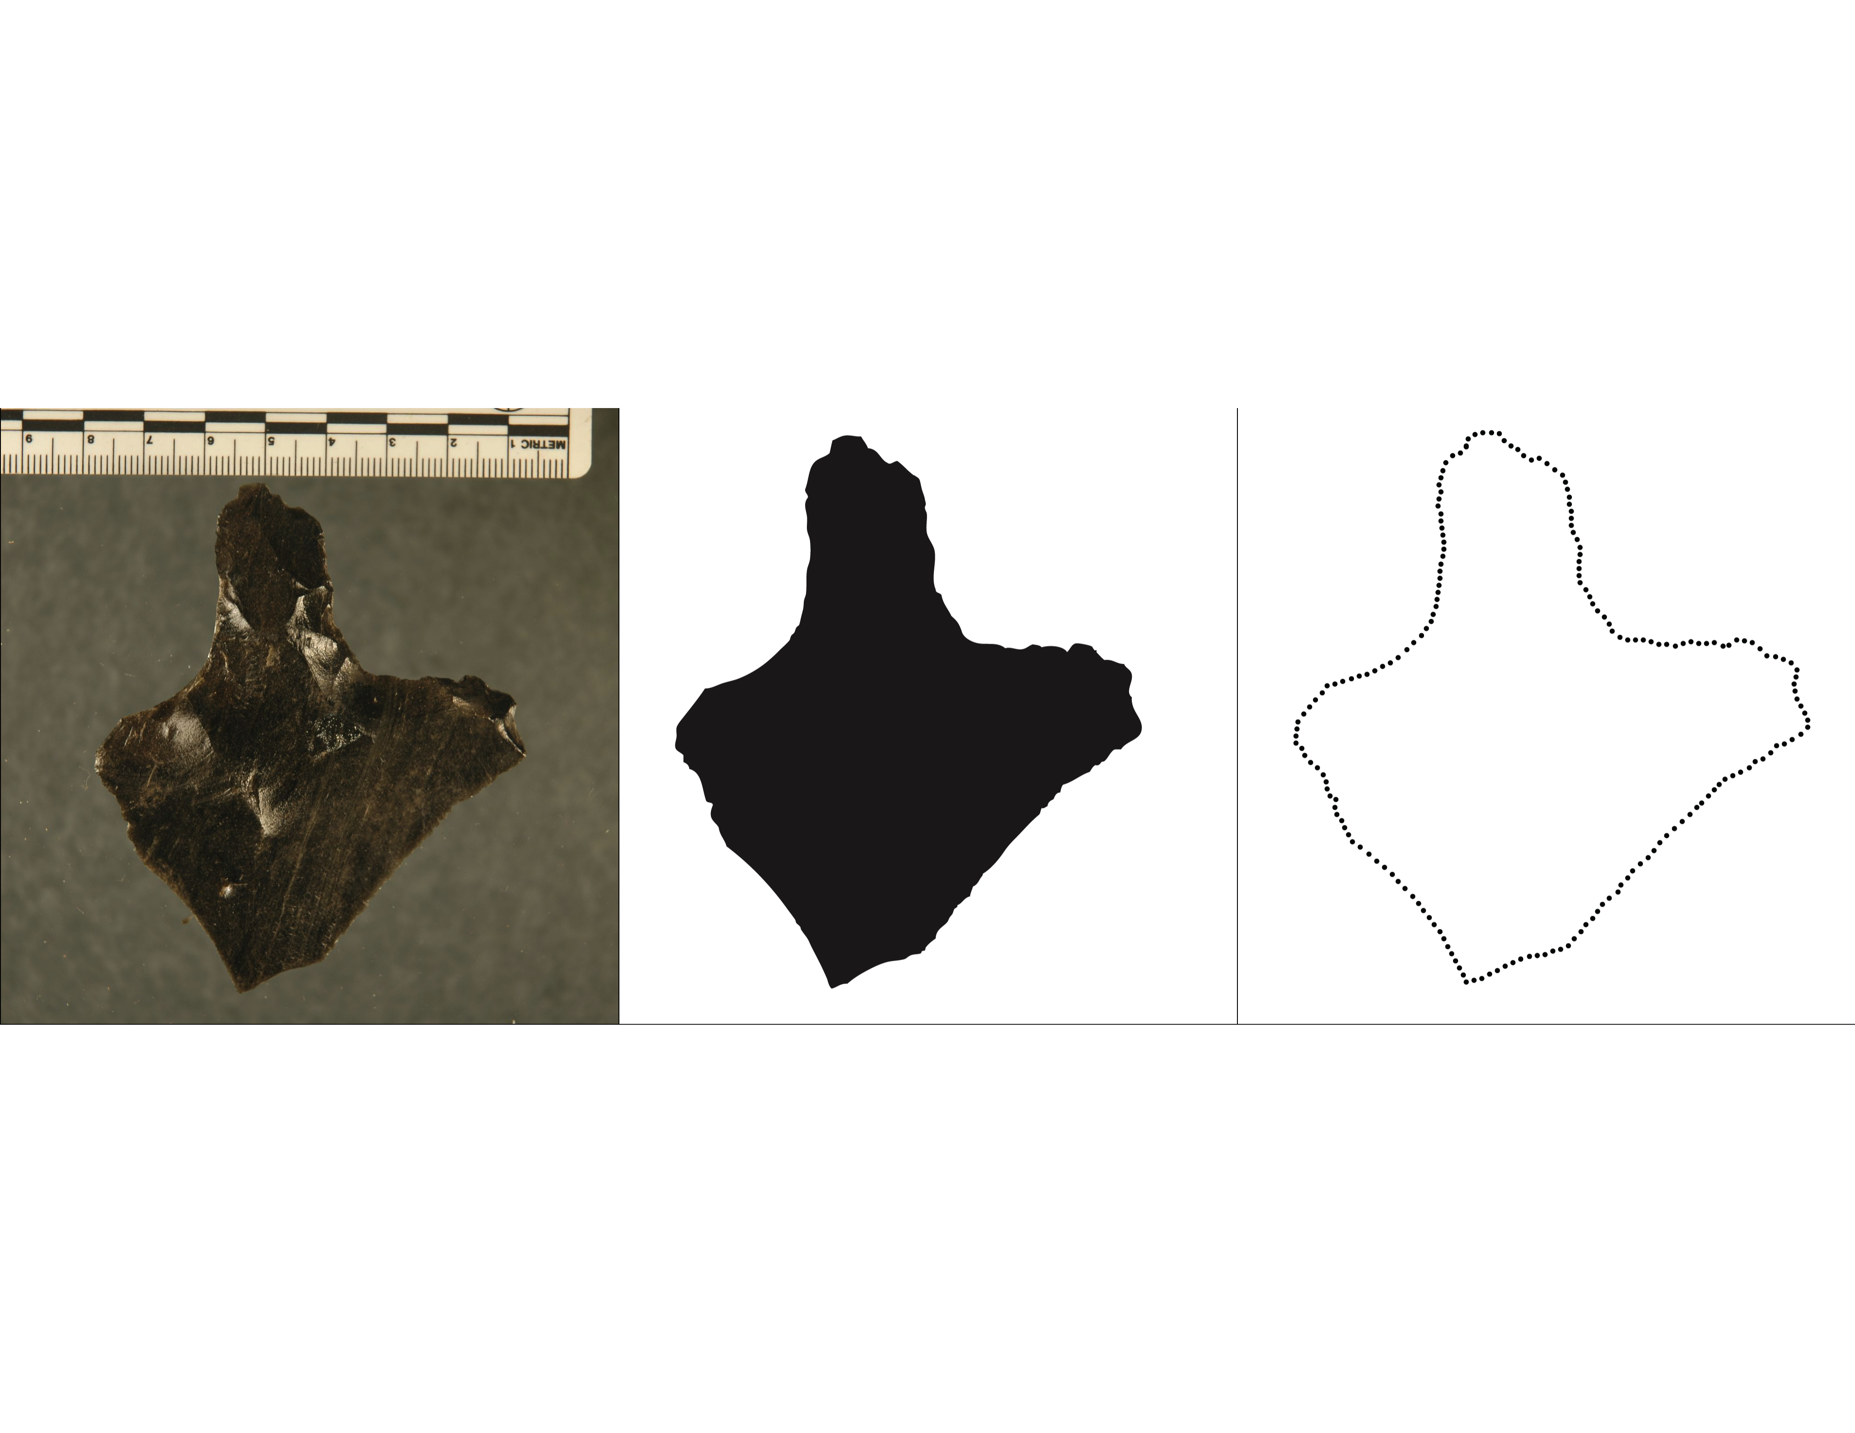

Figure 4. Measurement process used to generate *(x; y)* outline coordinates for each *mata’a* image.

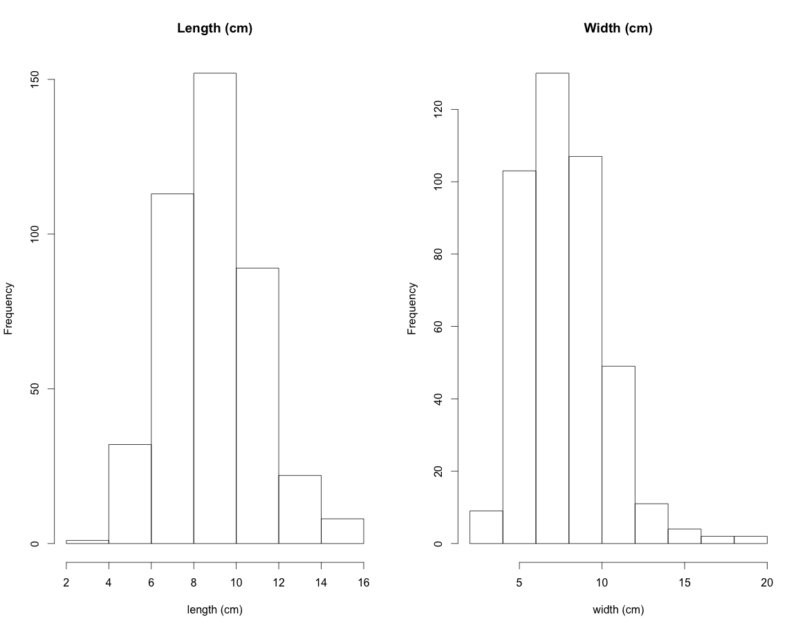

Figure 5. *Mata’a* lengths and widths.



Figure 6. Superimposed *mata’a* outlines from Rapa Nui. For comparison, all *mata’a* are aligned at the center point of the haft where it meets the blade.

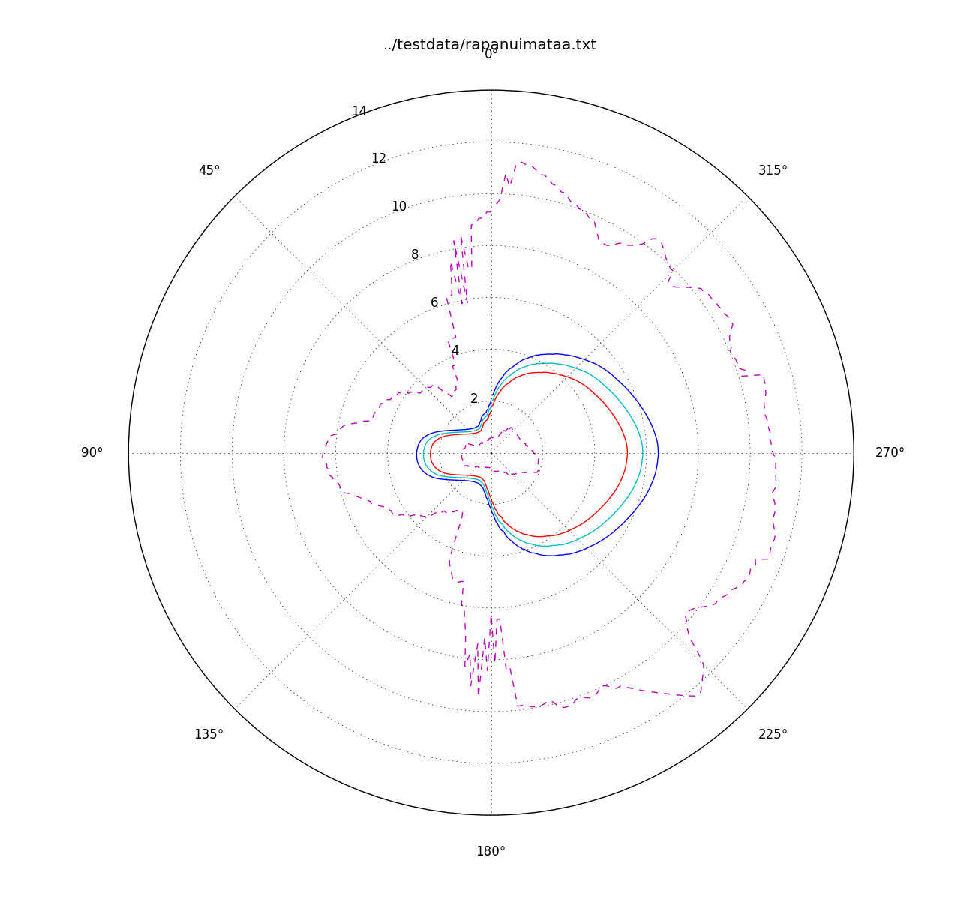

Figure 7. Variability in *mata’a* shape shown with mean and 95% confidence intervals. Note that the 95% confidence intervals are shown with exaggerated differences between the values to illustrate areas with greater variance versus those with more constrained shape. Here, the area at the base of the stem where it meets the blade is the most constrained portion of *mata’a* shape while the stem length and blade are more variable.

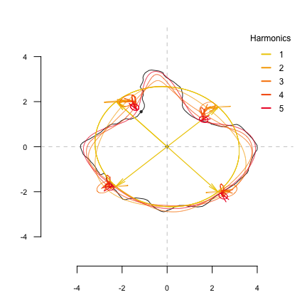

Figure 8. Elliptic Fourier analysis is based on the sum of harmonic trigonometric functions, fitting separately x and y coordinates, that together define ellipses in the plane. Five harmonics are here shown at four locations on the original outline of a *mata’a*. As the number of harmonics is increased the reconstruction better approximates the original shape outline.

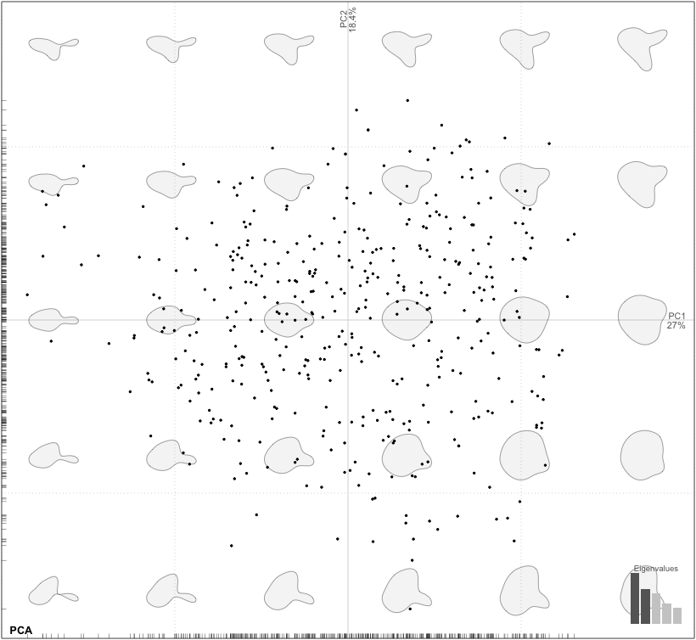

Figure 9. First two principal components (PC1 and PC2 are on the x- and y-axis, respectively) for the Rapa Nui *mata’a*.

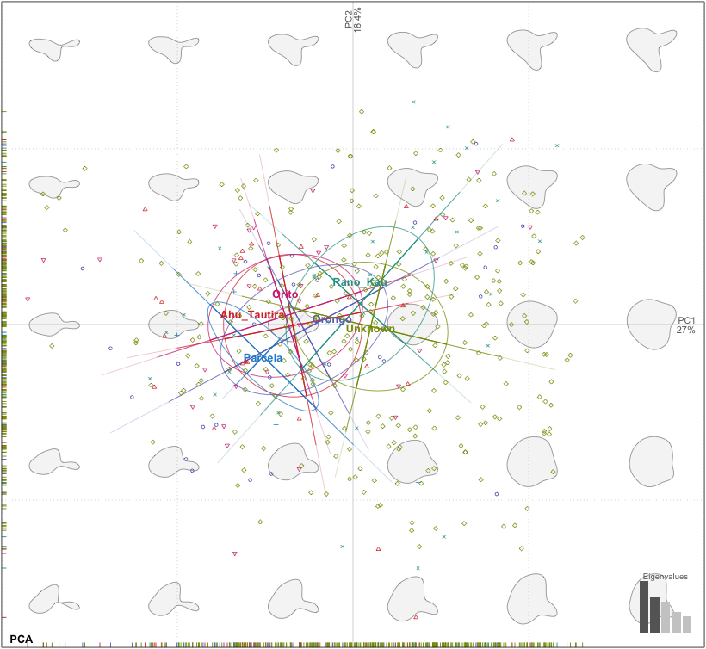

Figure 10. First two principal components of *mata’a* grouped by site location.

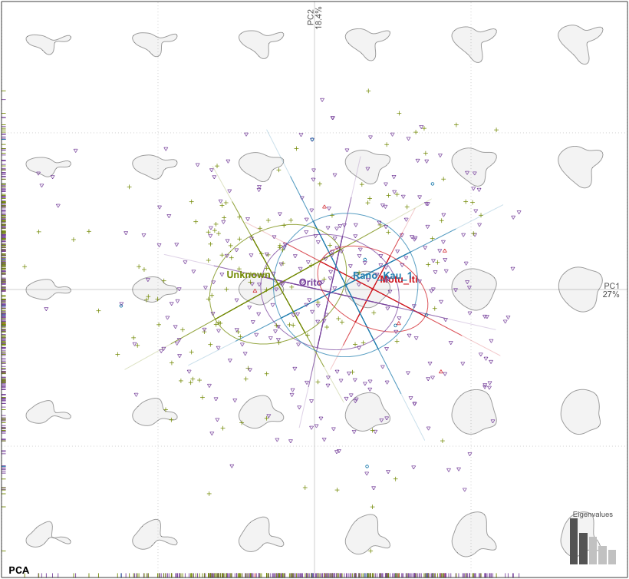

Figure 11. First two principal components of *mata’a* grouped obsidian source.

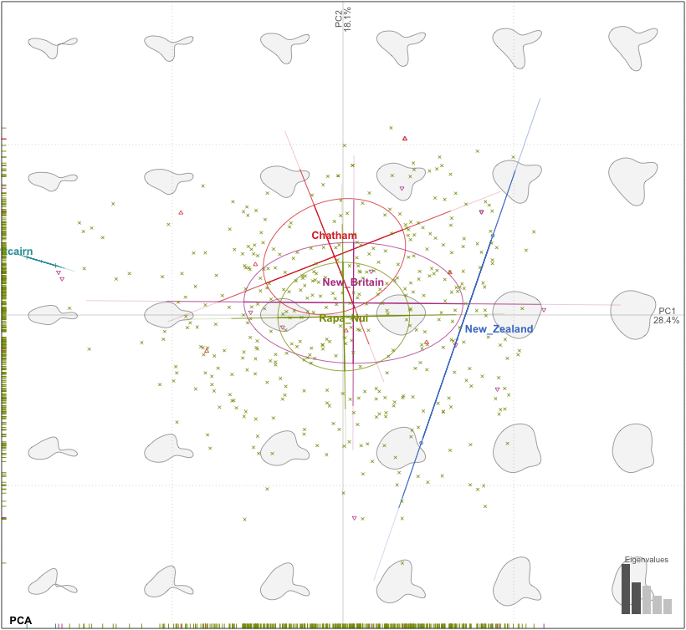

Figure 12: Factorial maps depicting the two principal components (PC1 and PC2 are the x- and y-axis, respectively) of morphological variation for stemmed lithic shaped objects from Rapa Nui, New Britain, New Zealand, Chatham and Pitcairn Islands. The shapes are reconstructed from the factorial map using the first two component axes.

# SUPPLEMENTARY INFORMATION

1*Momocs* builds upon techniques developed by Claude (2008) and reviewed by Bowman (2009). Bonhomme incorporated functions from Claude's work into an integrated framework and a standalone R package. The package's vignette *A* *Graphical Introduction to Momocs and Outline Analysis Using R* (Bonhomme 2012) provides an extensive description of the functions of the package. All of the R code and data for this project is freely available at <https://github.com/clipo/mataaMorphometrics>.

2While our measured outlines are composed of 200 points, *Momocs* interpolates between points to locate distances from centroids at even intervals. In addition, since all measurements are based on georeferenced coordinates, planimetric measure (such as width or length) can be calculated. Additional image analysis techniques to isolate object outlines point to the strong potential for automation of the measurement process, greatly increasing the ability to characterize large assemblages. With large numbers of measures of radial distances made relative to the *mata’a* centroids, we then calculate a statistical summary for each angle to assess variability in relative dimensions.

3In morphometrics, Fourier treats closed outlines as periodic functions. If you start somewhere on the outline and follow it, you will pass again and again by the same starting point and thus periodic functions can describe this outline. These functions can use a variety of descriptive data for the outline: the distance of any point on the outline to the centroid of the shape, the variation of the tangent angle for any point, or the (x/y) position on the plane (Rohlf & Archie 1984). For an outline shape, a periodic function is obtained and can be decomposed (and thus described) by Fourier series.

Fourier series, however, work on continuous functions. Since in practice shape is measured on a finite number of discrete points on a plane (in our case, x/y coordinates), a discrete equivalent to Fourier series is used in morphometrics. A given number of points called pseudo-landmarks have to be sampled along the outline before computing shape analysis. All Fourier decomposition then result in an harmonic sum of trigonometric functions associated with harmonic coefficients. They are (usually) normalized to remove homothetic, translational or rotational differences between shapes. Two or four coefficients, depending on the approach used, are obtained for each calculated harmonic and can then be considered as quantitative variables. The geometrical information contained in the outlines are thus quantified and can be analyzed with classical multivariate tools.

To conduct Fourier analysis, we must estimate the number of necessary harmonics after examining the spectrum of harmonic Fourier power. The power is proportional to the harmonic amplitude and can be considered as a measure of shape information. As the rank of the harmonic increases, the power decreases and adds less and less information. We can evaluate the minimum number of harmonics required to best approximate the shape. In the case of the *mata’a* and using x/y position for points on the outline as the data set, 12 harmonics provide a good reconstruction of the overall shape (Figures S2 and S3).

# References Cited

Bonhomme, V. 2012. *A graphical introduction to Momocs and outline analysis using R.* <http://www.vincentbonhomme.fr/Momocs/vignettes/>.

Bonhomme, V., S. Picq, C. Gaucherel & J. Claude 2014. Momocs: Outline analysis using R. *Journal of Statistical Software* 56: 1–24.

Rohlf, F. & J. Archie 1984. A comparison of Fourier methods for the description of wing shape in mosquitoes (Diptera: Culicidae*). Systematic Biology* 33(3): 302–17.

Table S1: Rapa Nui *mata’a* included in analyses by site and by repository (N=423).

|  |  |  |  |  |  |  |  |
| --- | --- | --- | --- | --- | --- | --- | --- |
|  |  | *Site* | | | | | |
|  |  | Ahu Tautira | Orito | Orongo | Rano Kau | Parcelas | Unknown |
| *Collection* | Bishop Museum | 0 | 0 | 0 | 0 | 0 | 291 |
| P. Sebastian Englert Museum | 25 | 31 | 29 | 33 | 0 | 0 |
| Heyerdahl & Ferdon 1961a | 0 | 0 | 0 | 0 | 0 | 8 |
| Field Surveys (Hunt & Lipo 2006 | 0 | 0 | 0 | 0 | 6 | 0 |

Table S2: *Mata’a* included in analyses by obsidian source and collection.

|  |  |  |
| --- | --- | --- |
|  |  | *Collection* |
|  |  | Bishop |
| *Obsidian Source* | Motu Iti | 5 |
| Orito | 279 |
| Rano Kau 1 | 7 |

Table S3. Stemmed lithic tools from other island locations in the Pacific (N=24).

|  |  |  |
| --- | --- | --- |
| Island | Number | Source |
| Chatham | 8 | Jones 1981 |
| New Britain | 12 | Torrence 2009a, 2009b, 2013 |
| New Zealand | 2 | Jones 1981 |
| Pitcairn | 2 | Heyerdahl & Ferdon 1961b |

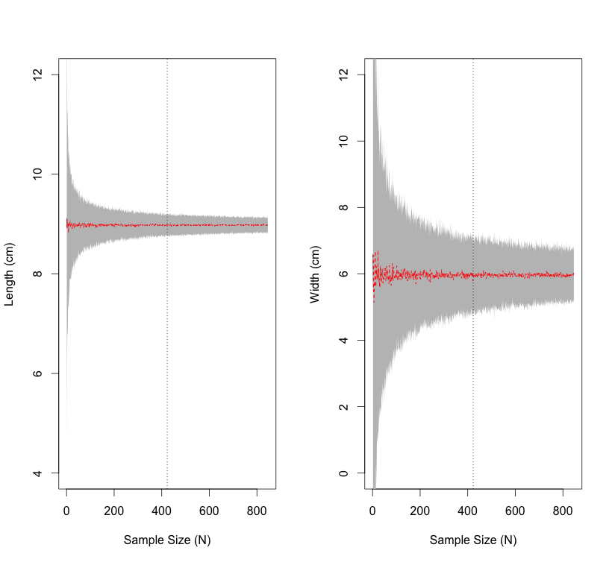

Figure S1. Sample size and *mata'a* parameter estimation. By repeatedly resampling the collection with an increasing number of samples until we reach twice the original sample size while also comparing changes in the 95% confidence intervals of length and width for each set of resampled assemblages, we can assess the degree to which metrics change with increasing samples. The sample size (N=423) shown via the dotted lines) of *mata'a* appears to be sufficient to estimate variability in the basic shapes.

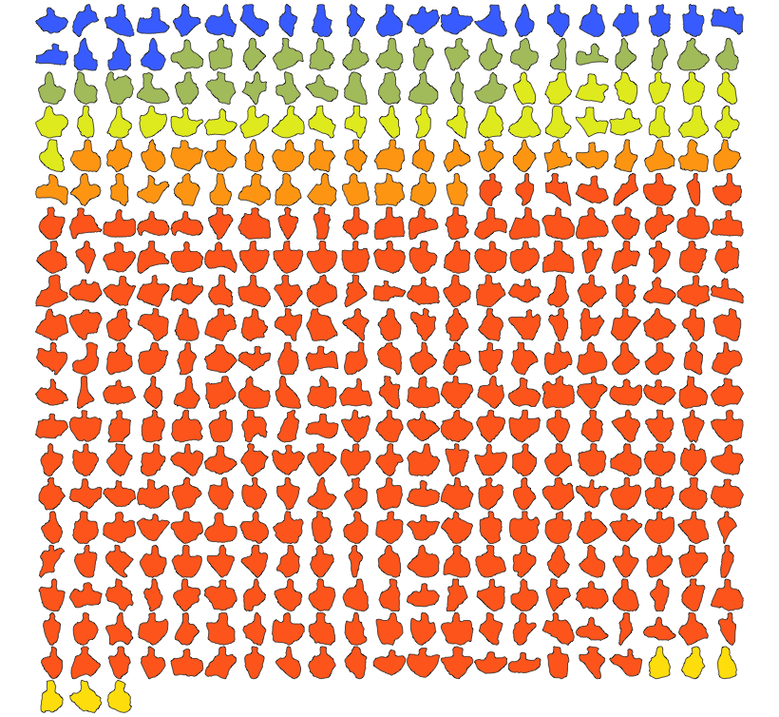

Figure S2. *Mata’a* included in the current analyses. The 5 colors indicate the collection locations on Rapa Nui (Blue=Ahu Tautiri, Green=Orito, Yellow/Green=Orongo, Orange=Rano Kao, Red=Location only known to the level of the island, Yellow=Parcela).

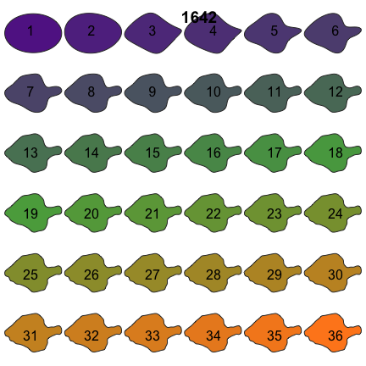

Figure S3. *Mata’a* reconstructed from different numbers of harmonics. Twelve harmonics provide a satisfactory reconstruction.

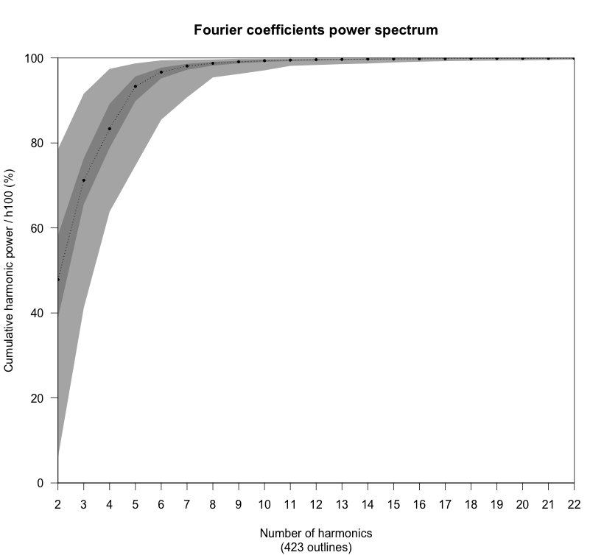

Figure S4. Cumulated harmonic Fourier power calculated from Rapa Nui *mata’a*. The 12 first harmonics gather nearly 100% of the harmonic power. Maxima, minima and medians are also plotted.